Tappy Keystroke Data Preprocessing
The Tappy Keystroke Dataset comprises millisecond-precision timing logs of typing sessions from Parkinson’s disease (PD) patients and healthy controls. For each keystroke transition, three fundamental temporal metrics are captured (1) Hold Time (HT), the duration between key press and release events representing finger contact time on a single key; (2) Up-Down interval (UD), the latency between releasing one key and pressing the subsequent key, quantifying the inter-key flight time where the finger moves through air; and (3) Digraph Duration (DD), the total elapsed time from the initial key press to the next key press, calculated as DD = HT + UD, representing the complete inter-keystroke cycle as shown in Figure 1. These measurements target distinct parkinsonian motor symptoms: prolonged HT reflects finger freezing or tremor; elevated UD captures "micro-freezes" during finger transit; and increased DD indicates overall bradykinesia (slowness of movement).
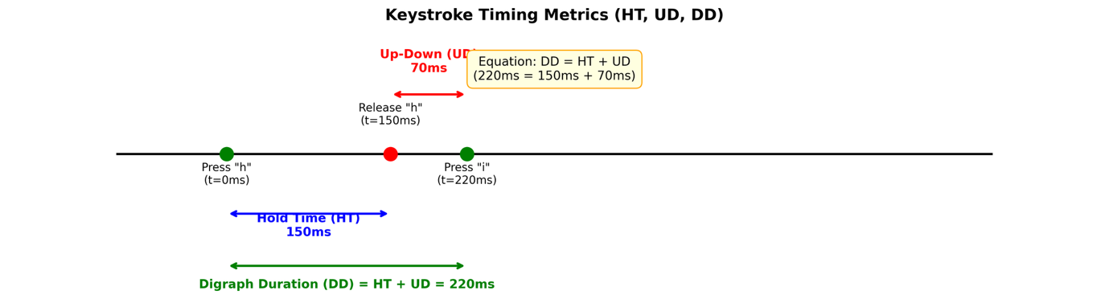
Figure 1: Timing metrics timeline with HT, UD, DD brackets

To transform this raw sequential data into machine-learning-ready feature vectors, a structured preprocessing pipeline was implemented comprising data parsing, temporal segmentation via sliding windows, and statistical feature extraction as shown in Figure 2. The Raw input consists of user metadata files containing binary PD labels and session-specific transition logs. The parsing stage extracts seven core variables per keystroke: dataset source, anonymised subject identifier, session ID, binary PD label (1 = Parkinson’s, 0 = healthy), HT (milliseconds), DD (milliseconds), UD (milliseconds), and digraph classification (KK, KS, SK, SS, where K = alphanumeric key, S = spacebar). Rigorous outlier filtering excludes physiologically implausible timings (HT <10ms or >2000ms, DD <10ms or >5000ms, UD <-500ms or >5000ms) to ensure mechanical artifacts do not confound motor symptom detection.
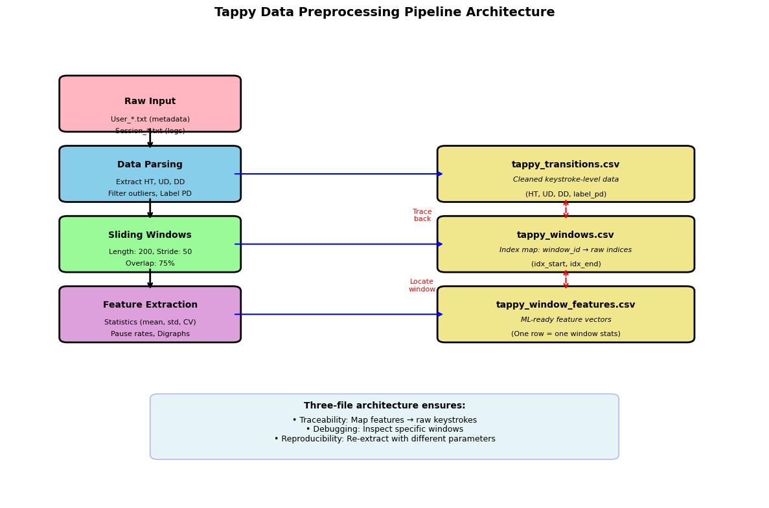
Figure 2: Pipeline architecture showing three CSV outputs

To capture the dynamic, non-stationary nature of parkinsonian symptoms, bradykinesia, freezing episodes, and timing variability, continuous keystroke streams were segmented using a sliding window approach as shown in Figure 3. Windows were defined with a fixed length of 200 consecutive keystrokes and a stride of 50 keystrokes, yielding 75% overlap between adjacent windows. This methodology ensures that transient pathological events are not lost at window boundaries (an event occurring at keystroke 199 would be captured in both window 1-200 and window 51-250), while simultaneously augmenting the training dataset size by generating approximately four times more samples than non-overlapping segmentation would permit.
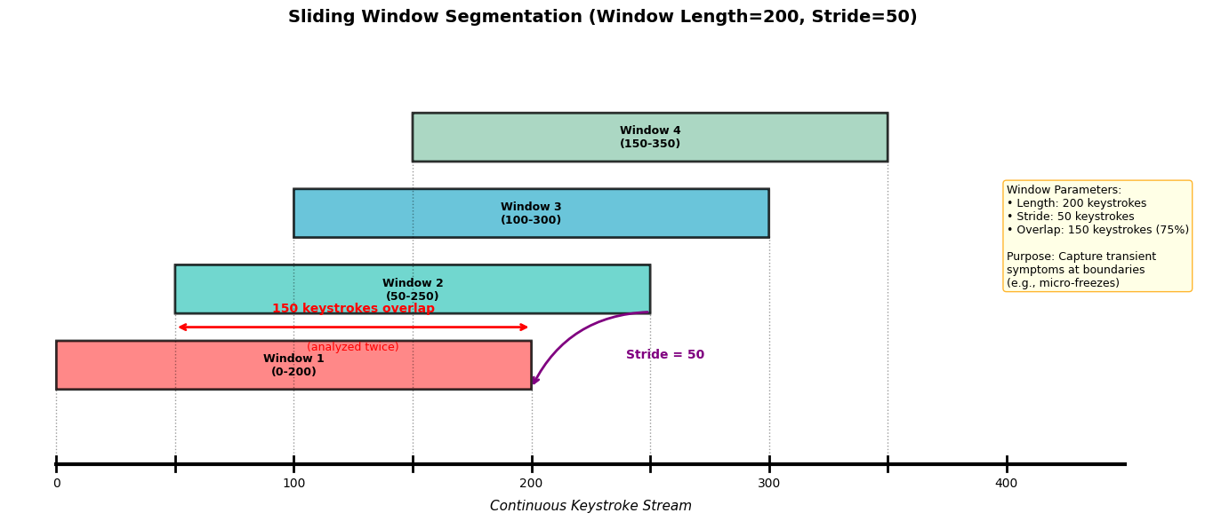
Figure 3: sliding windows showing overlap
For each temporal window, descriptive statistics were computed: mean, standard deviation, median, interquartile range (IQR), coefficient of variation (CV), and 95th percentile for HT, DD, and UD intervals. Pause-rate features quantified the frequency of extended latencies exceeding 500ms, 750ms, and 1000ms thresholds to detect freezing episodes. Digraph transition rates captured motor pattern variations across hand-spacebar combinations (KK, KS, SK, SS), revealing changes in spacebar usage characteristic of PD.
The pipeline generates three complementary CSV outputs: (1) tappy_transitions.csv containing cleaned keystroke-level data; (2) tappy_windows.csv serving as an index map correlating each window identifier to its specific row indices; and (3) tappy_window_features.csv comprising the final ML-ready matrix. This three-file architecture ensures full traceability from derived features back to raw behavioural observations, enabling error analysis while providing robust multimodal input for fusion with speech-based classifiers.
